ABAP Technical Documentation: Open PO List Report
Program Name: zsv_po_open_list.abap | Object Type: ABAP Executable Report

1. Executive Summary
This document provides the technical specifications, source code, detailed step-by-step logic explanation, and risk analysis for the ABAP report zsv_po_open_list.abap. The report fetches Purchase Order (PO) header and line-item details from SAP standard tables EKKO and EKPO based on user-selected vendor and document date ranges, and displays the output using the SAP ALV Grid standard class (CL_SALV_TABLE).
2. System Screenshot & Execution Environment
The screenshot below captures the development environment (SAP Business Application Studio / IDE) displaying the technical analysis plan for `zsv_po_open_list.abap`:
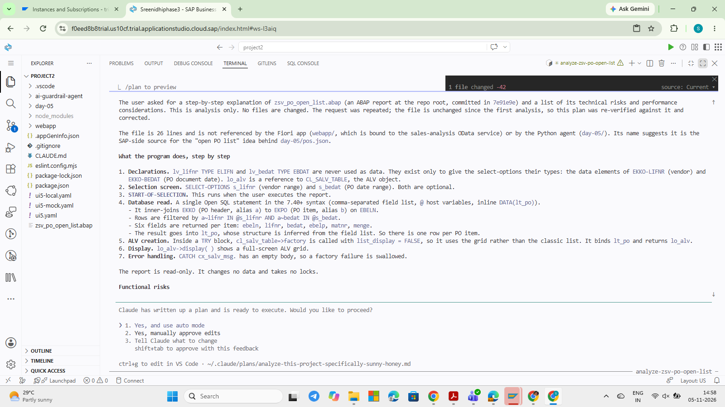
Figure 1: IDE Terminal Screenshot displaying PO List Program Analysis Plan
3. Source Code (zsv_po_open_list.abap)
DATA: lv_lifnr TYPE ELIFN,
lv_bedat TYPE ebdat.
DATA: lo_alv TYPE REF TO cl_salv_table.
SELECT-OPTIONS: s_lifnr FOR lv_lifnr,
s_bedat FOR lv_bedat.
START-OF-SELECTION.
SELECT a~ebeln, a~lifnr, a~bedat,
b~ebelp, b~matnr, b~menge
FROM ekko AS a
INNER JOIN ekpo AS b
ON b~ebeln = a~ebeln
WHERE a~lifnr IN @s_lifnr
AND a~bedat IN @s_bedat
INTO TABLE @DATA(lt_po).
TRY.
CALL METHOD cl_salv_table=>factory
EXPORTING
list_display = IF_SALV_C_BOOL_SAP=>FALSE
IMPORTING
r_salv_table = lo_alv
CHANGING
t_table = lt_po.
lo_alv->display( ).
CATCH cx_salv_msg.
ENDTRY.

4. Step-by-Step Technical Analysis
1. Declarations: lv_lifnr TYPE ELIFN and lv_bedat TYPE EBDAT are declared as reference variables. They are never populated with data directly; they exist solely to define data types for the selection screen input fields (vendor number and PO purchasing document date). lo_alv is declared as a reference variable to class CL_SALV_TABLE for ALV display.
2. Selection Screen: SELECT-OPTIONS s_lifnr and s_bedat create standard range selection tables on the selection screen for filtering by Vendor (ELIFN) and PO Purchasing Date (EBDAT). Both selection parameters are optional.
3. Event Trigger: START-OF-SELECTION event block triggers when the user executes the report (F8).
4. Database Read: A single Open SQL query (using SAP NW 7.40+ inline declaration syntax) performs an INNER JOIN between EKKO (PO Header, alias a) and EKPO (PO Item, alias b) on EBELN (PO Number):
• Filters rows using range conditions: a~lifnr IN @s_lifnr AND a~bedat IN @s_bedat.
• Selected fields: EBELN (PO Number), LIFNR (Vendor), BEDAT (PO Date), EBELP (Item Number), MATNR (Material Number), MENGE (Quantity).
• Target table lt_po is created dynamically with inline declaration @DATA(lt_po), inferring structure directly from the selected field list (one row per PO item).
5. ALV Instance Creation: Inside a TRY...ENDTRY exception block, static factory method cl_salv_table=>factory creates the ALV instance. Parameter list_display = IF_SALV_C_BOOL_SAP=>FALSE sets the output display mode to standard ALV Grid (rather than standard classic list). Internal table lt_po is bound to output reference lo_alv.
6. Display: Method call lo_alv->display( ) renders the interactive full-screen ALV Grid display to the end user.
7. Error Handling: The CATCH cx_salv_msg block catches ALV display runtime errors. Currently, the catch block is empty, swallowing exceptions silently if factory instantiation fails.
5. Data Dictionary & Field Mapping
Table | Field Name | Data Element | Description
EKKO | EBELN | EBELN | Purchasing Document Number (PO Number)
EKKO | LIFNR | ELIFN | Account Number of Vendor / Supplier
EKKO | BEDAT | EBDAT | Purchasing Document Date
EKPO | EBELP | EBELP | Item Number of Purchasing Document
EKPO | MATNR | MATNR | Material Number
EKPO | MENGE | BSTMG | Purchase Order Quantity

6. Functional Risks & Optimization Recommendations
- Unrestricted Database Selection: If both s_lifnr and s_bedat selection fields are left blank by the user, the program will perform a full table scan on EKKO and EKPO, which can cause timeout dumps (TIME_OUT) or severe memory overflow in production systems.
- Silent Exception Handling: The CATCH cx_salv_msg block is empty. If the ALV fails to instantiate, the program terminates silently without notifying the user or logging an error message.
- Read-Only Operational Scope: The report is strictly read-only; it does not lock database tables, perform transactional updates, or validate user authorization checks (AUTHORITY-CHECK).

